Level
June 30
2017
Design
Document
Designer: Tu Linh Quach (Luciana Vessalius) GDS111 - Stephen Whittle

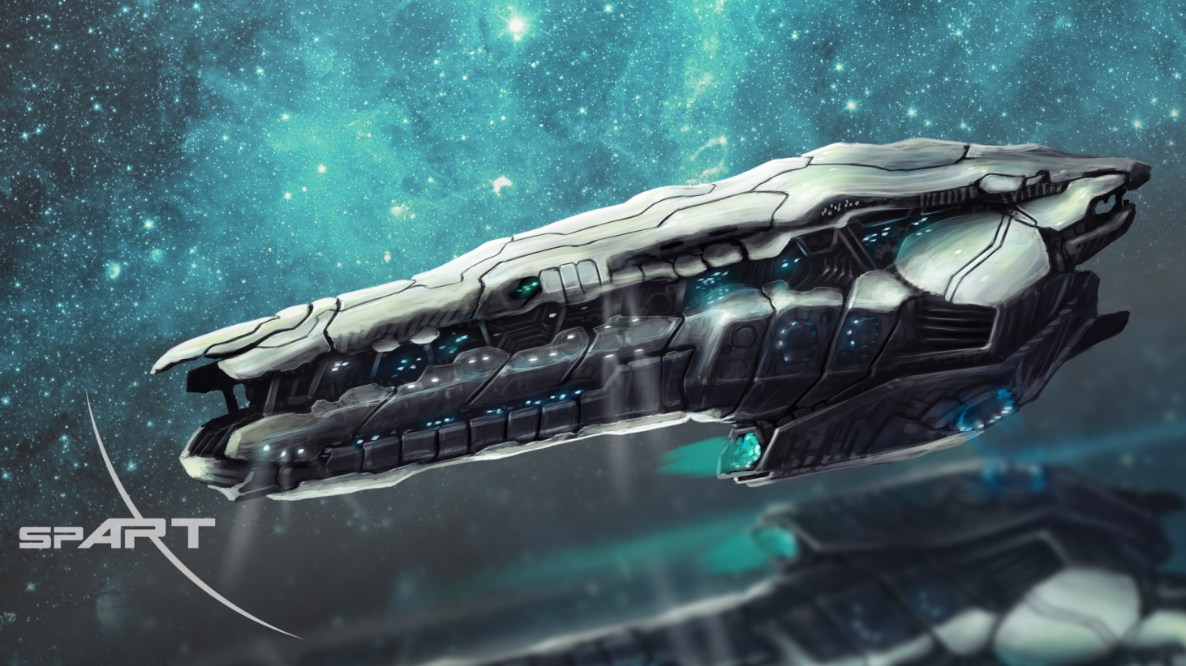
Space ©

Table of content
Quick Summary 3
Overview 3
Map design and Details 4
Altitude measurement (in general) 6
Map Explanation 6
Players Guidance 6
Map Callouts 7
(5): Experiment room 7
Simulation/Illustration (Experiment room) 8
(H): Hall (and elevator (E2)) 10
Simulation/Illustration (Hall) 11
(4): Storage 14
Simulation/Illustration (Storage) 15
(2) Private room 16
Simulation/Illustration (Private room) 17
(3) Meeting room 19
Simulation/Illustration (Meeting room) 20
(1): Control room 21
Simulation/Illustration (Control room) 22

Quick Summary
The Earth is under alien invasion and you (players) are abducted by them and brought to their space ship to another planet, at a different point of time. You wake up in an experiment glass tube where they confined and did experiment on you. Luckily, other experimental objects and you escape because some of strange uncontrollable power. You have to find yourself a way to survive and escape from that planet and also return to your time. While you are there, you find yourself a powerful power flows inside you and besides… you also find an extremely terrible secret…

Overview
- Unidentified planet, outside The Earth, distance: 7.3 billion light-years
- This level concentrates on alien’s space ship
- 25:35:55 pm, Janleros 55th , 2814
- Oxygen condition: Good
- Visibility - 100000 units
- Basic structure and theme: Sci-fi and fiction

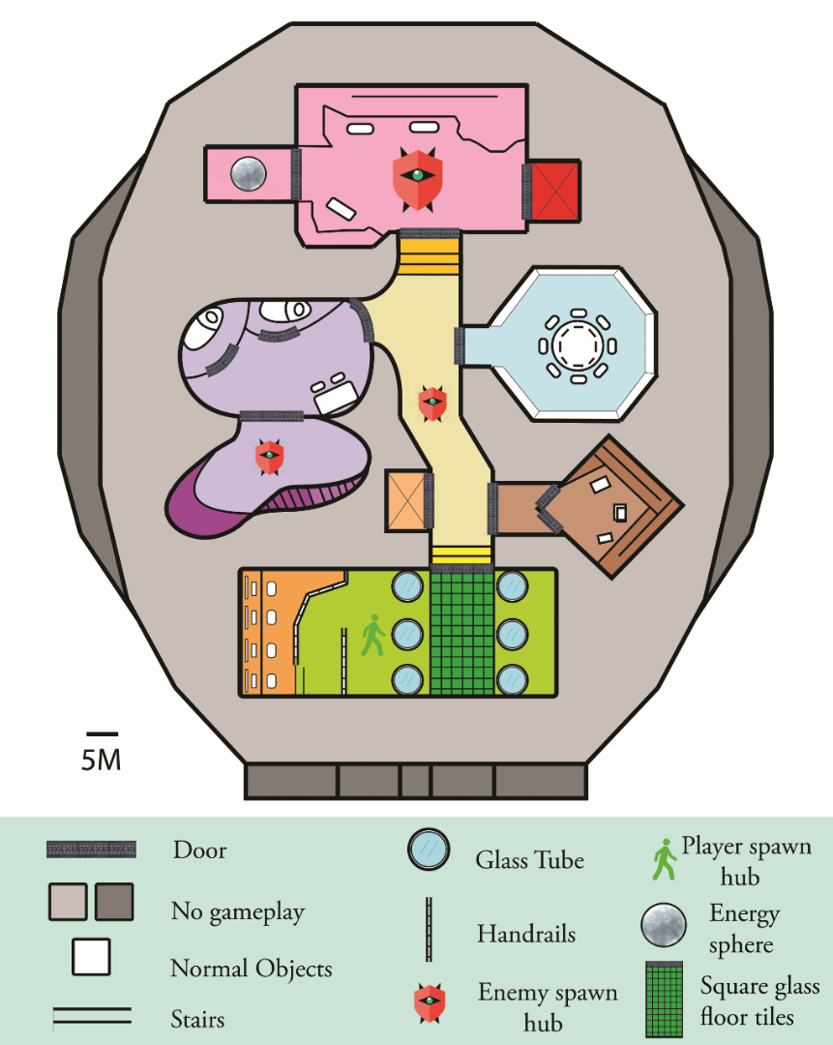
Maps Design and Detail

S3
S1
S2
5

4

E2
2b

2a

3

E1
H
1

Altitude measurement (in general)
- Original height (ground height): 0m
- The pink area (room (1)) is 20m lower than the other colors (or the ground) This number may smaller (or larger) than in real map.
- The room number (5) is 10m higher than other colors (or the ground) This number may smaller (or larger) than in real map.
Note: Illustration images are included (see Map Callouts)

Map Explanation
- (1): Control room
- (2): Private room
  - (2a): bed room
  - (2b): Observatory
- (3): Meeting room
- (4): Storage
- (5): Experiment room
- (H): Hall
- (S1): Stair 1
- (S2): Stair 2
- (S3): Stair 3
- (E1): Elevator 1
- (E2): Elevator 2

Players Guidance
- There will be a notification when the players come close to an active objects:
  - for unknown objects or unknown places
  - for alarming of threat around players

  - Lack of light area

  - for alarming of hazardous around players, players may die

  - Execute a function (example: Search (for objects on enemies’ bodies); Enter (the room, elevator))
E

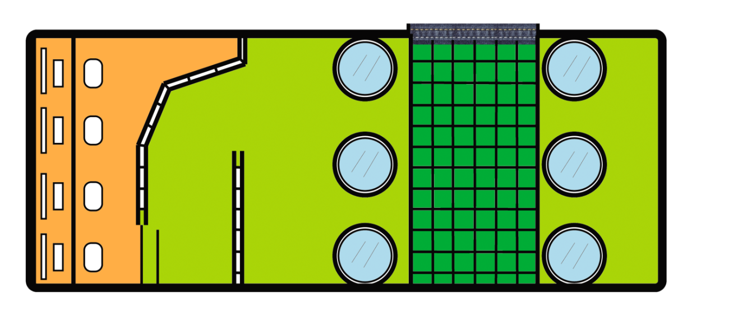
Map Callouts
(5): Experiment room
S3
- Height of the room: 5m, acreage: 50m x 20m
- Types of cover in this area can be desks, chairs, tables, computers, glass tubes (used for experimental objects).
- The glass floor tiles (dark green) can be used as a good perspective from top down view so that players can see what down there.
- This experiment room is also the very first place where players wake up after being abducted. That is also the reason why a “players spawn hub” is placed at this room. Also, player’s team will also appear at this spawn hub.
- (S3: stair 3) indicates a higher level of the orange area (1m higher), comparing with the yellow green area.
- Players can find their first weapon at the red star area. (Bio Rifle)
- There is no need for this part to execute.
- This room is 10m higher than normal areas (see Simulation/Illustration) to stimulate players’ imaginary, while they move down to the stairs, they may wonder themselves what down there because the below area is quite dark and lack of light (due to the damage). And also, this height decreases players’ perspective

- There is no longer an enemy spawn hub there.
Simulation/Illustration (Experiment room)
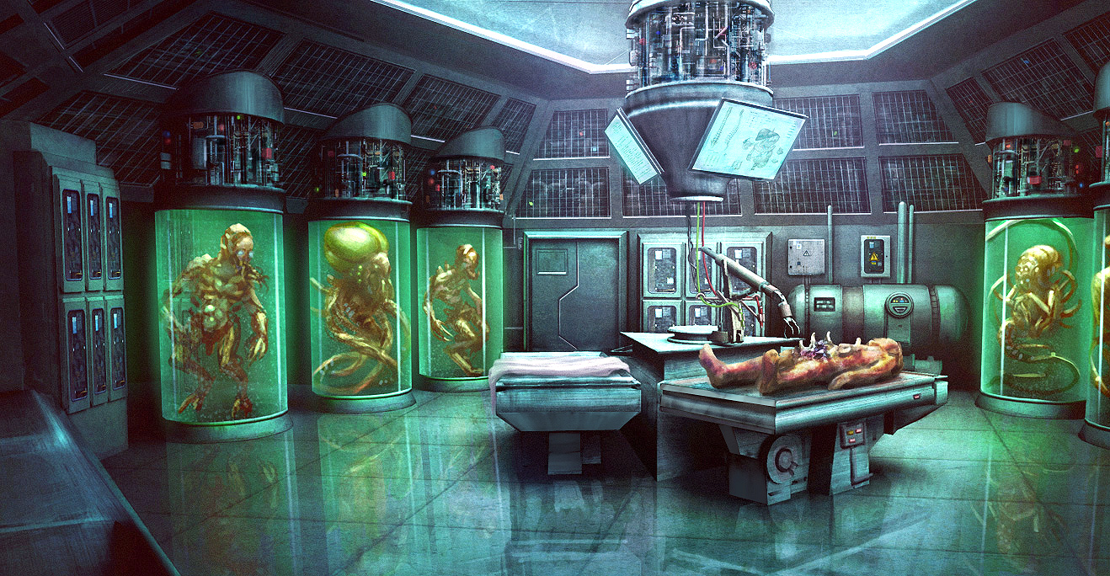
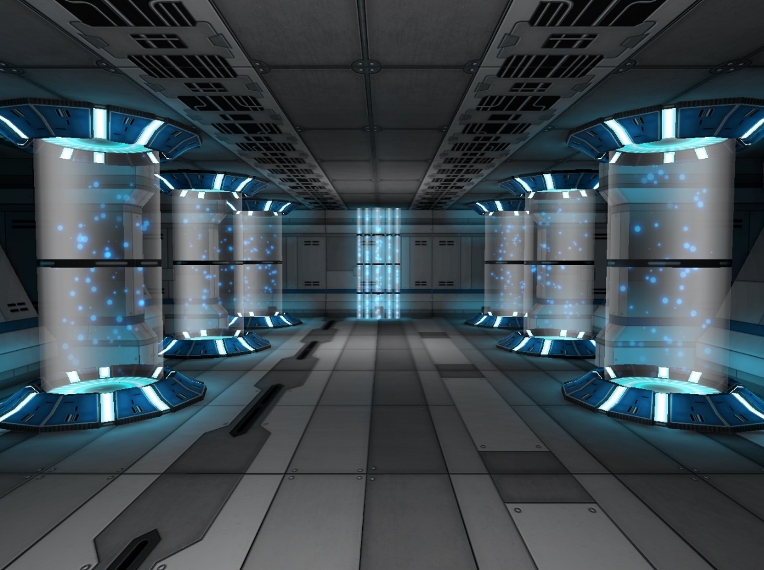
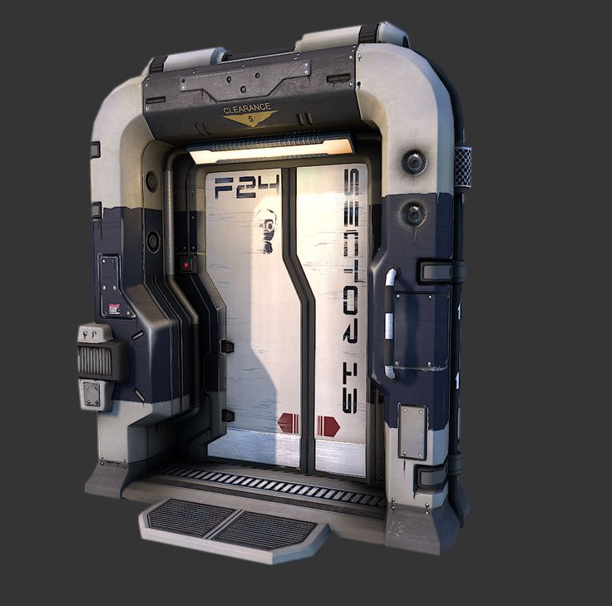
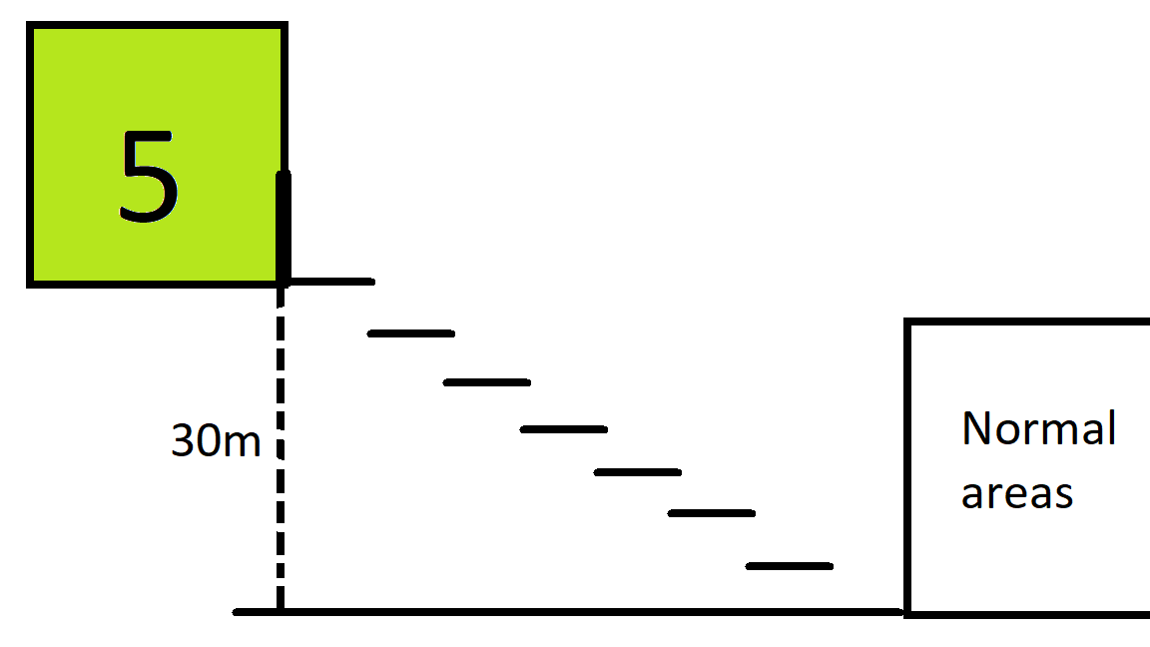
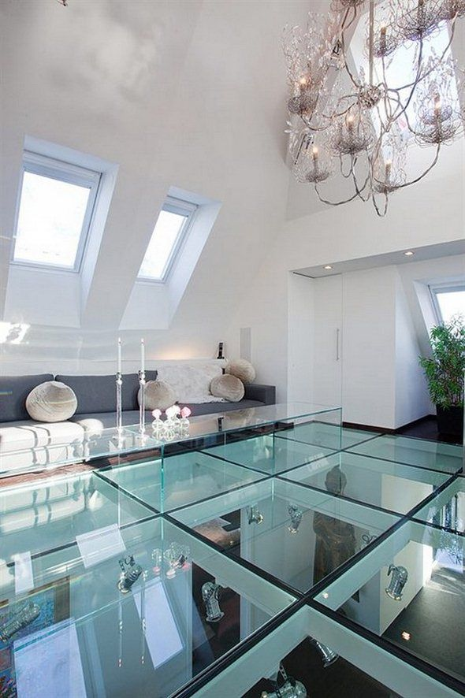
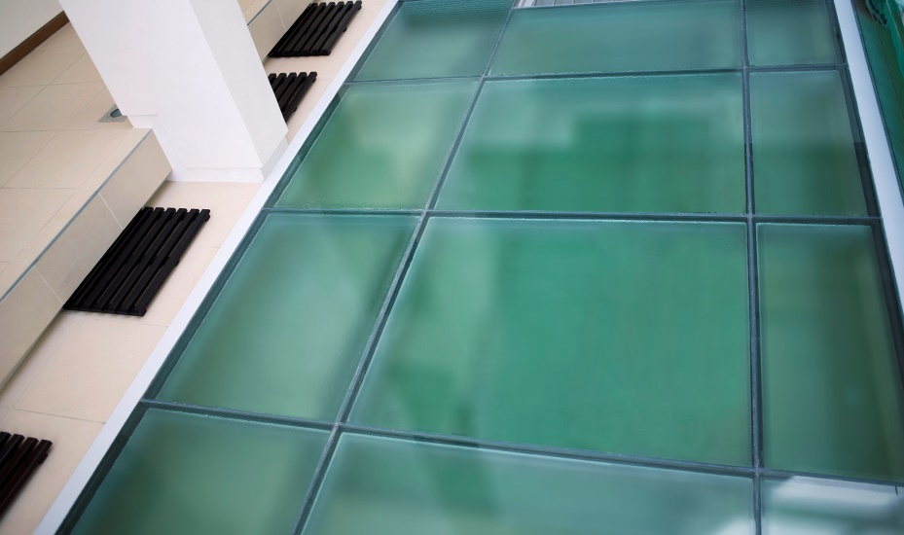
10m
5m

(H): Hall (and elevator (E2))
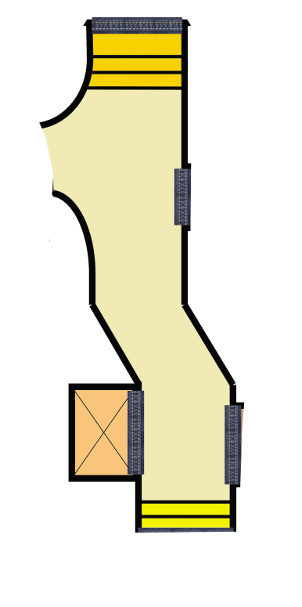

30m

E2

7m
- Height of the hall: 5m
- Long: 30m, width: 7m
- Types of cover in this area can be some sci-fi machines and sci-fi structure for the hall.
- The hall will be quite dark, smoke and blinking light are also elements which will be implemented to the hall (due to the damage).
- Enemy will appear at enemy spawn hub, . Players can destroy enemy team by their weapons.
- Players can use elevator 2 (E2) to go up or down levels. However, some level are locked and require objects or missions to open.

- Hall now has more blank doors and weapons are placed randomly outside this hall so that it will be suitable for multiplayer.

Simulation/Illustration (Hall)
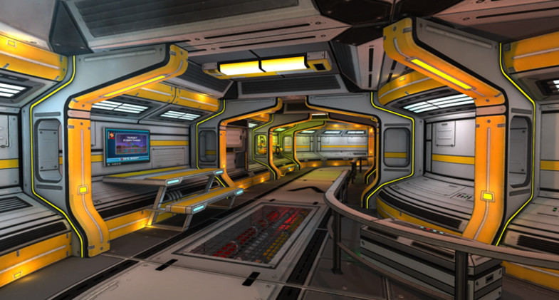
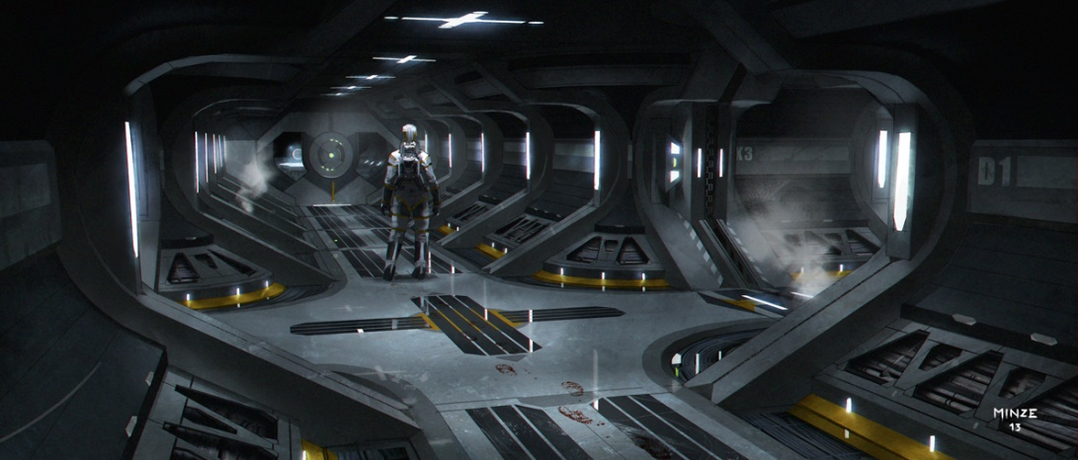
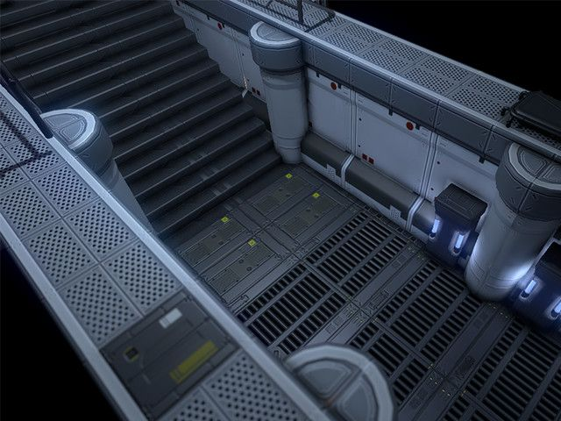
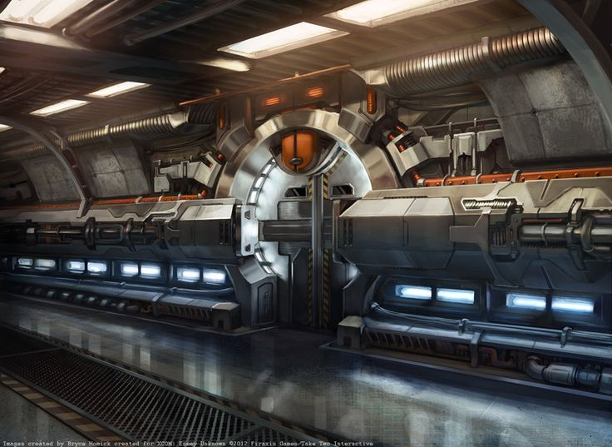
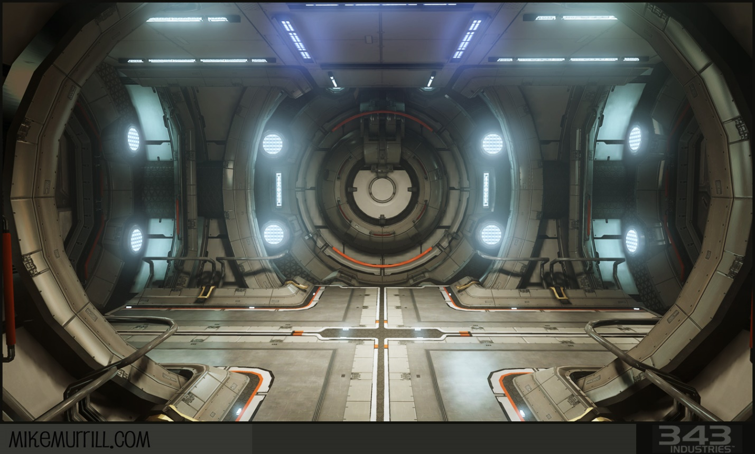

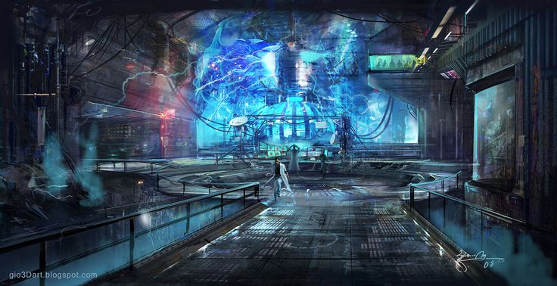
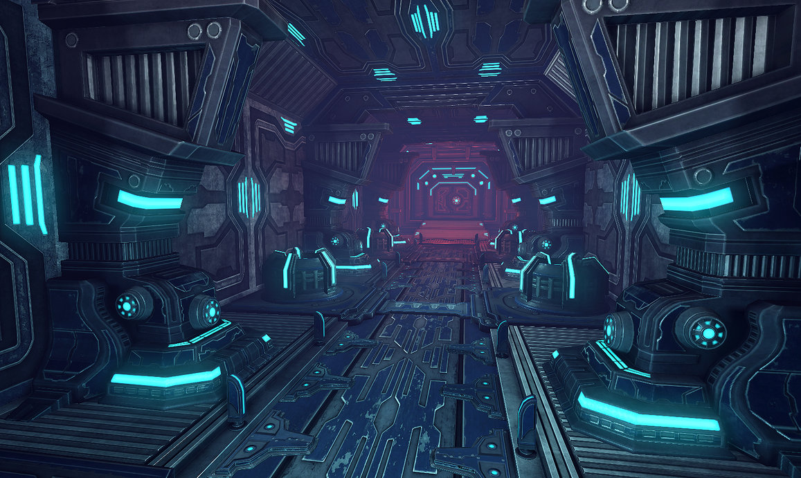
(4): Storage
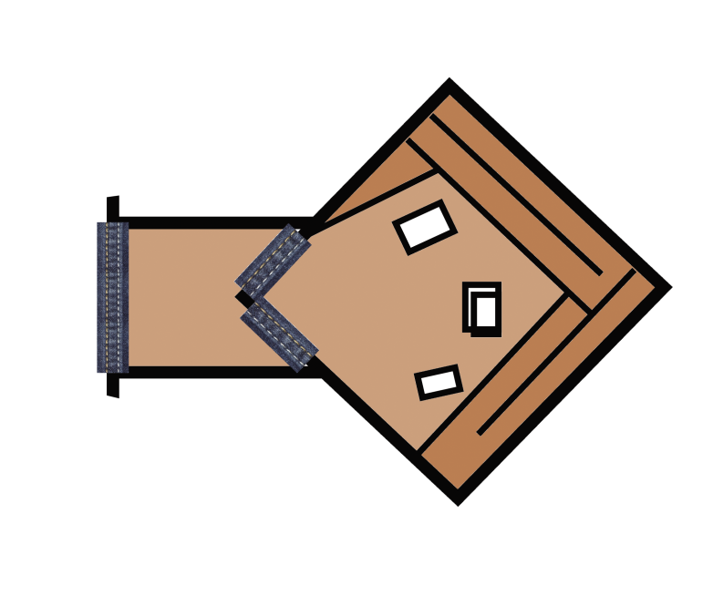

20m

- Height of the room: 10m may be lower in real map
- Acreage: 15m x 15m, Long (see captions): 20m
- The dark brown area is 5m higher than the floor (light brown area).
- Types of cover in this area are weapons for player to pick up.
- Players can find and equip them to increase power.

- Weapons can be found here are Enforcer, Impact Hammer, Link Gun, Stinger Minigun, Bio Rifle, Flak Cannon, Rocket Launcher, Snipper Rifle, Translocator, Light Rifle, Grenade Launcher, Redeemer and so on (not too much weapons for a room in real map)

Simulation/Illustration (Storage)
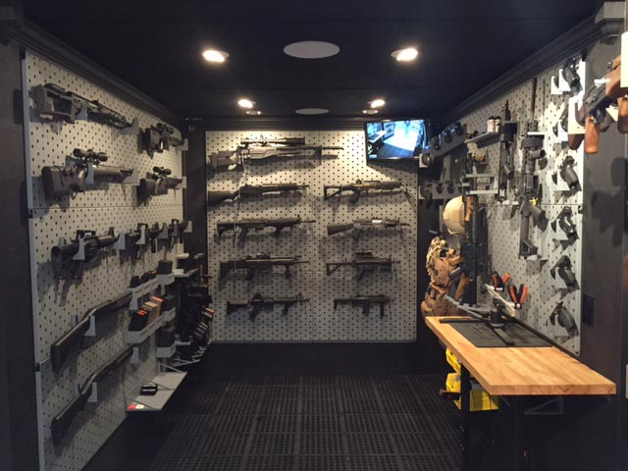

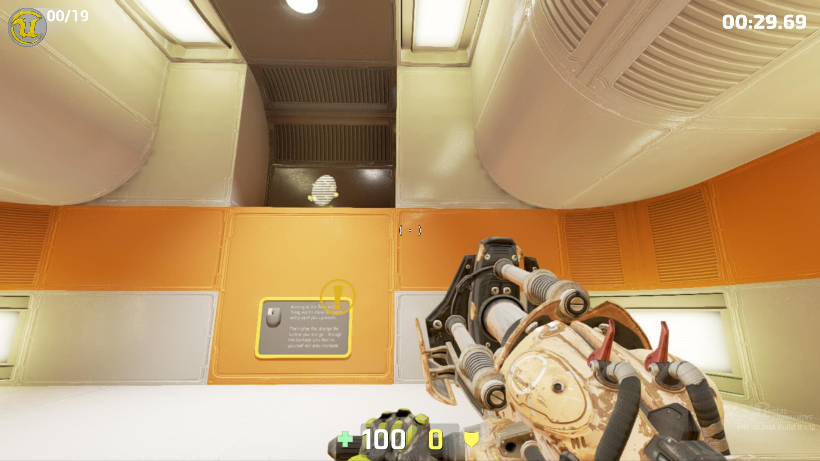
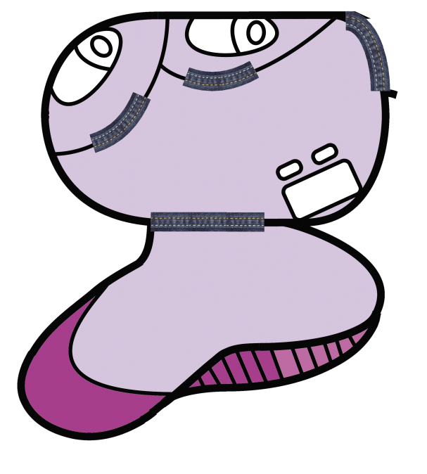
(2) Private room

2a: bed room

2b: Observatory

- Height of the room: 5m
- Acreage: 20m x 15m (2a)
23m x 10m (2b)
- Types of cover in this area can be beds, desks, computers and some basic objects for a private room
- Especially, in Observatory, there is big glass window to look out the space to create a “sci-fi feeling” for players.

- In the bed room, collectible objects (key to control room) are placed. Player can turn on the light in this room because it is quite dark

Simulation/Illustration (Private room)
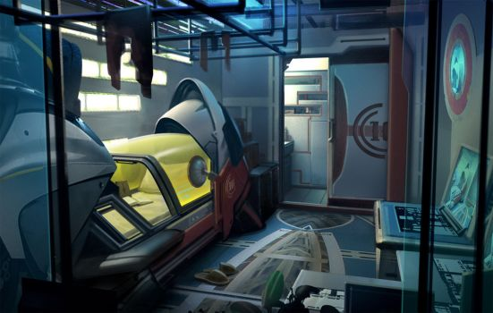
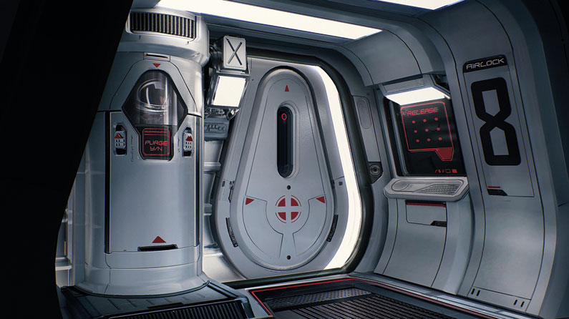
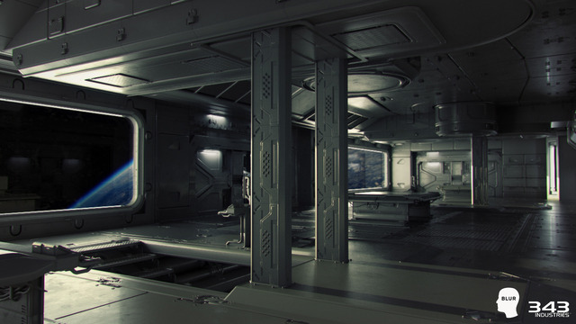
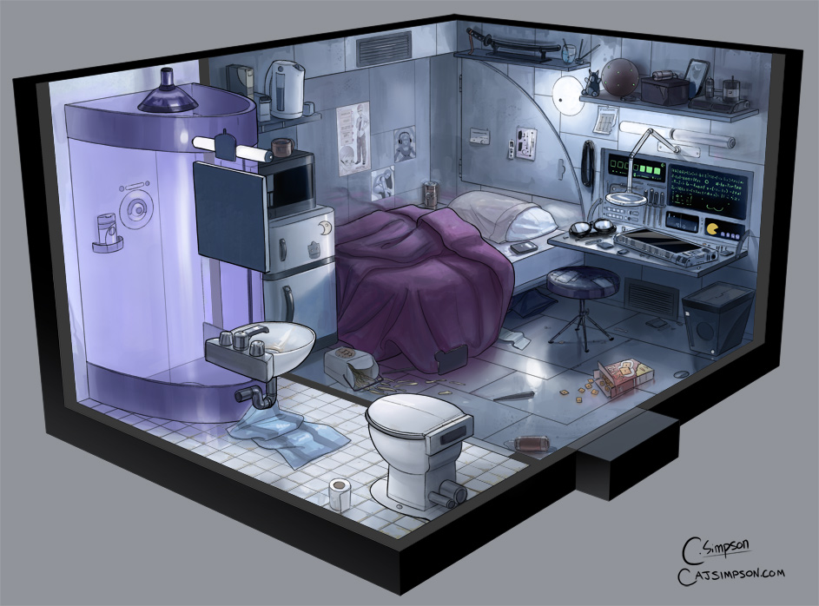
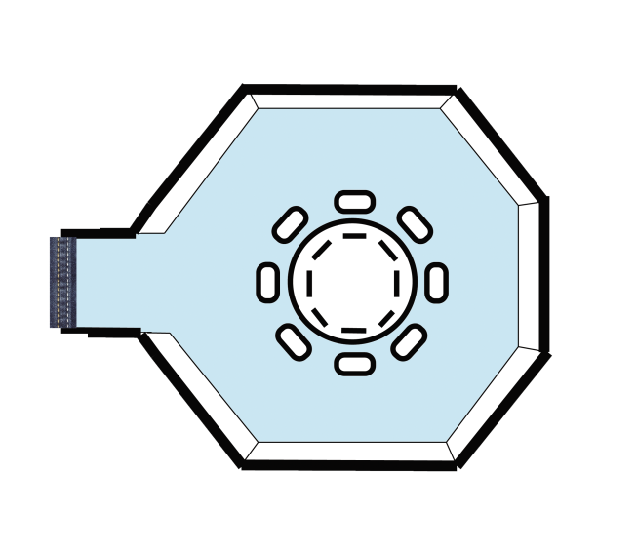
(3) Meeting room
18m

15m

- Height of the room: 5m
- Long: 18m, width: 15m
- Types of cover in this area can be table, computers and some basic objects for a meeting room
- Especially, there are big glass windows to look out the space to create a “sci-fi feeling” for players. Players can go through the window (suitable for multiplayer)
- Collectible objects are placed.

Simulation/Illustration (Meeting room)
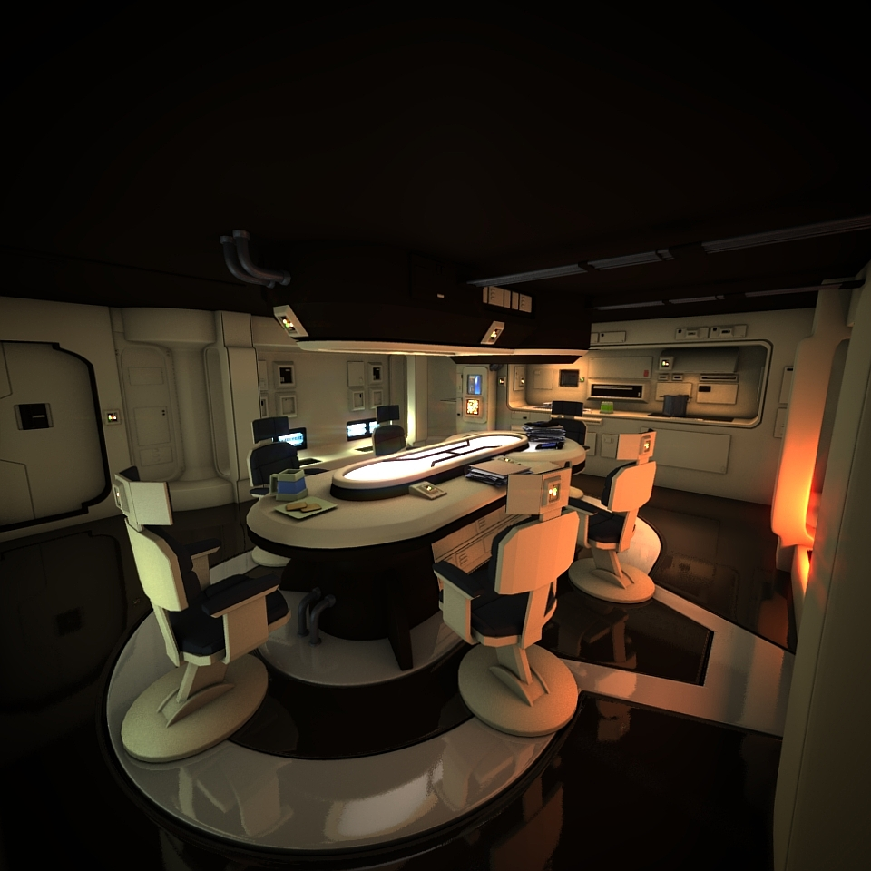

(1): Control room
1

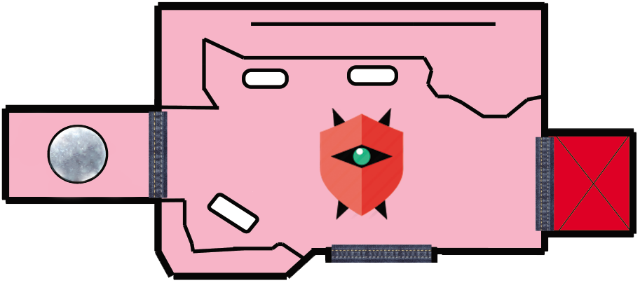
1a: Energy Sphere
1b: Secret elevator
- The first thing about this room is that it is not accessible and requires (or code) key to open the door.
- Types of cover in this area can be control tables, which is placed along the room, and some chairs for sitting. Besides, a secret elevator is placed. It is tightly closed and very difficult to have a security code to open the elevator door.
It also takes numerous steps to have key/code to open.

- Play has to hack the main computer to take permission of control by using the key in the restroom (Can be applied for multiplayer) and they win.
- The energy sphere in (1a) keeps mostly energy source for whole space ship. And it cannot be destroyed. Players can charge their weapons or armors here.
- This room is 20m lower than normal areas (see Simulation/Illustration) and quite dark (due to the damage). This will create a nervous feeling for players. And also, it will restrict players from getting an access to that room.

.2 C

Simulation/Illustration (Control room)
